<http://ec2-user@ec2-54-92-193-67.compute-1.amazonaws.com:8080/>

1.

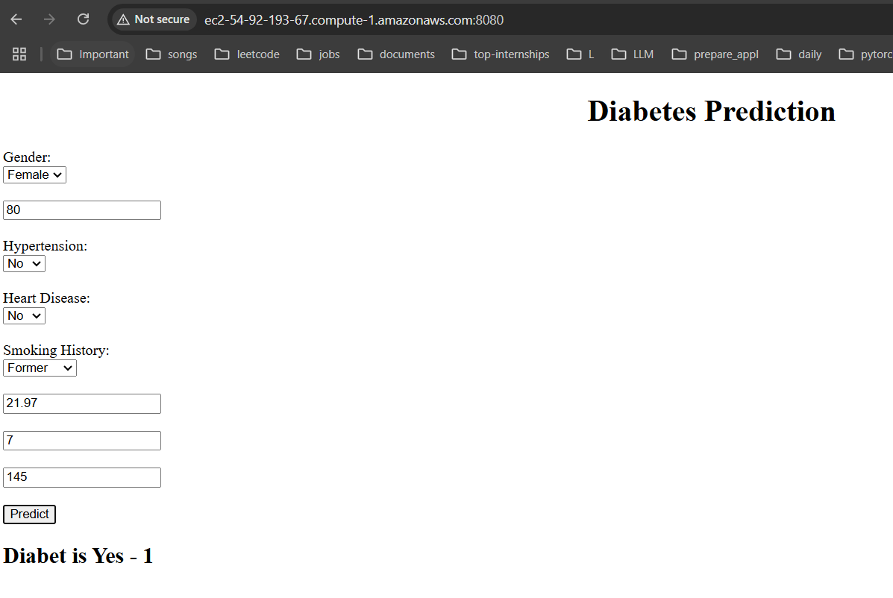

2.

